**DFA MINIMIZATION**

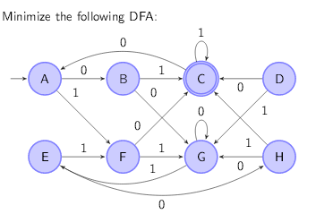

**TRANSITION TABLE**

|  |  |  |
| --- | --- | --- |
|  | **INPUT** | |
| **STATES** | **0** | **1** |
| **-A** | **B** | **F** |
| +C | A | C |
| D | C | G |
| E | H | F |
| F | C | G |
| **G** | **G** | **E** |
| H | G | C |
| B | G | C |

**O – EQUIVALENCE**

{C} , {A,B,D,E,F,G,H}

**1 – EQUIVALENCE**

{C} , {A,E,G}, {B,H}, {D,F}

**2 – EQUIVALENCE**

{C}, {A,E},{G}, {B,H}, {D,F}

**3 – EQUIVALENCE**

{C}, {A,E},{G}, {B,H}, {D,F}

**MINIMIZED TRANSITION TABLE**

|  |  |  |
| --- | --- | --- |
|  | **INPUT** | |
| **STATES** | **0** | **1** |
| -{A,E} | {B,H} | {D,F} |
| G | G | {A,E} |
| {B,H} | G | C |
| {D,F} | C | G |
| +C | {A,E} | C |

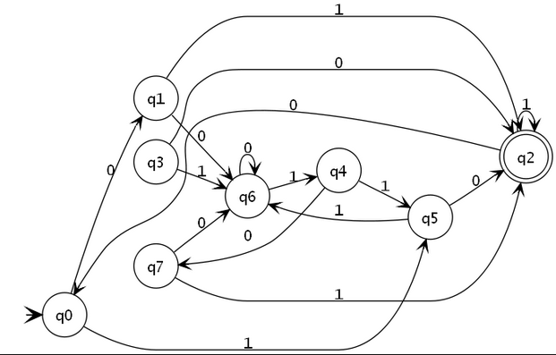

**TRANSITION TABLE**

|  |  |  |
| --- | --- | --- |
|  | **INPUT** | |
| **STATES** | **0** | **1** |
| **-q0** | **q1** | **q5** |
| q1 | q6 | q2 |
| +q2 | q0 | q2 |
| q3 | q2 | q6 |
| q4 | q7 | q5 |
| q5 | q2 | q6 |
| **q6** | **q6** | **q4** |
| q7 | q6 | q2 |

**O – EQUIVALENCE**

{q2}, {q0, q1, q3, q4, q5, q6, q7}

**1 – EQUIVALENCE**

{q2}, {q0, q4, q6}, {q1, q7},{q3,q5}

**2 – EQUIVALENCE**

{q2}, {q0, q4}, {q6}, {q1, q7}, {q3, q5}

**3 – EQUIVALENCE**

{q2}, {q0, q4}, {q6}, {q1, q7}, {q3, q5}

**MINIMIZED TRANSITION TABLE**

|  |  |  |
| --- | --- | --- |
|  | **INPUT** | |
| **STATES** | **0** | **1** |
| -{q0,q4} | {q1,q7} | {q3,q5} |
| {q6} | {q6} | {q0,q4} |
| {q1,q7} | {q6} | {q2} |
| {q3,q5} | {q2} | {q6} |
| +{q2} | {q0,q4} | {q2} |